**Experiment No: 05**

**Aim:** Write a program to implement A* Search Algorithm.

**Theory**:

* A* search algorithm is one of the best algorithm which is used in path-finding and graph traversals.
* It evaluates nodes by combining g(n), the cost to reach the node, and h(n), the cost to get from the node to the goal :

**f(n) = g(n) + h(n)**

* g(n) : these represents the exact cost of the path from the starting node to any node n.
* h(n) : these represents the heuristic estimated cost from node n to goal node.
* f(n) : lowest cost in the neighboring node n.
* Thus, if we are trying to find the solution node, first is the node with the lowest value of g(n) + h(n)

**Example (Problem Map):**

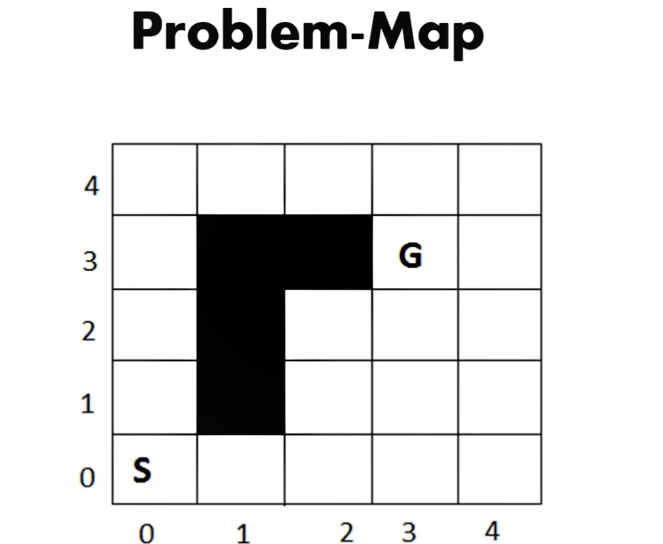

**Algorithm / Pseudo code :**

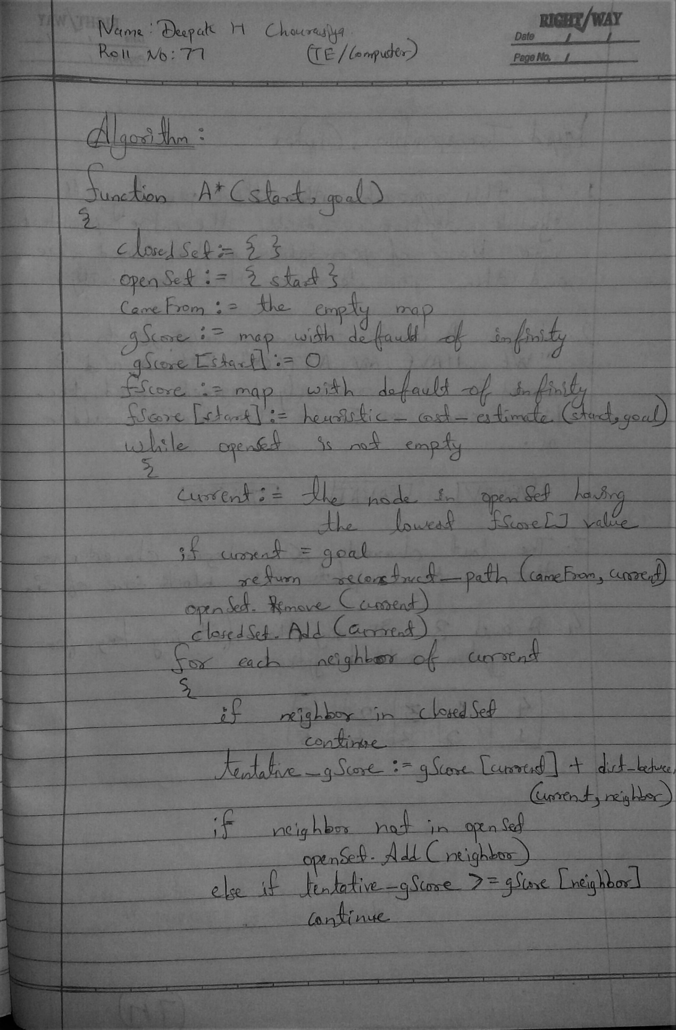

**(Algorithm Part : 1)**

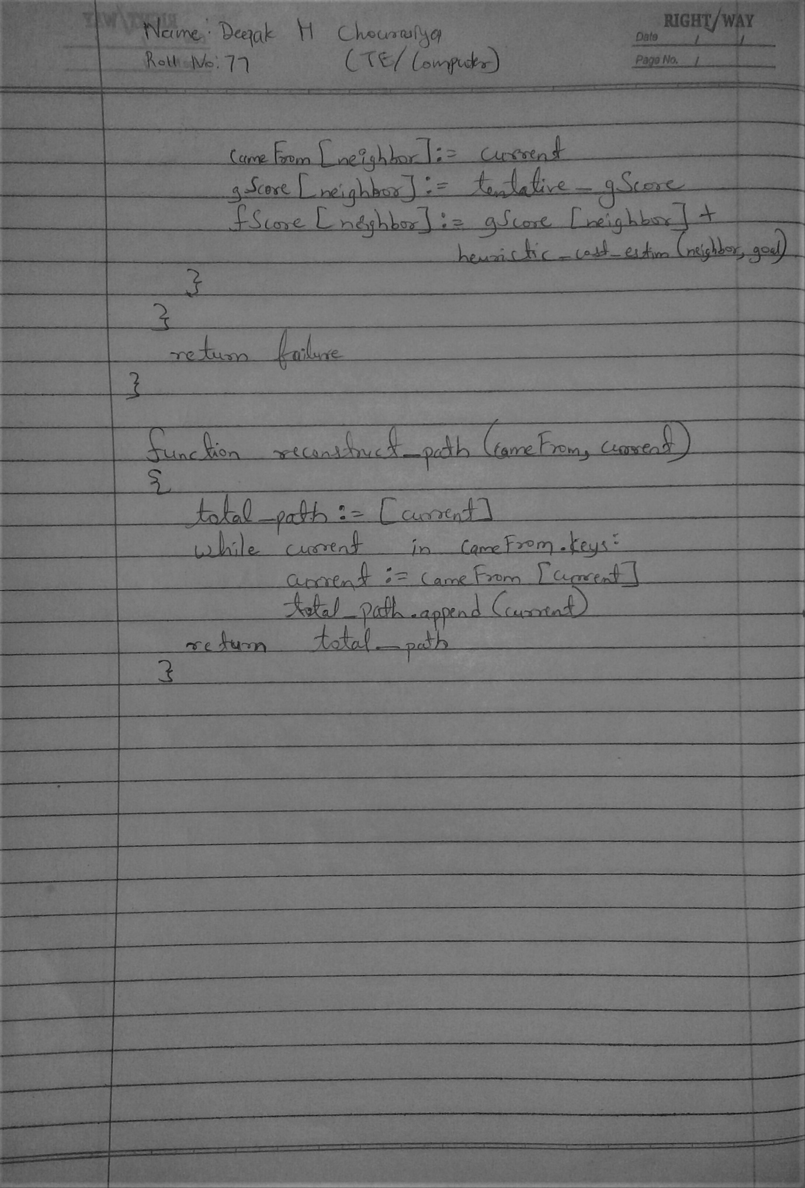

**(Algorithm Part : 2)**

**Implementation:**

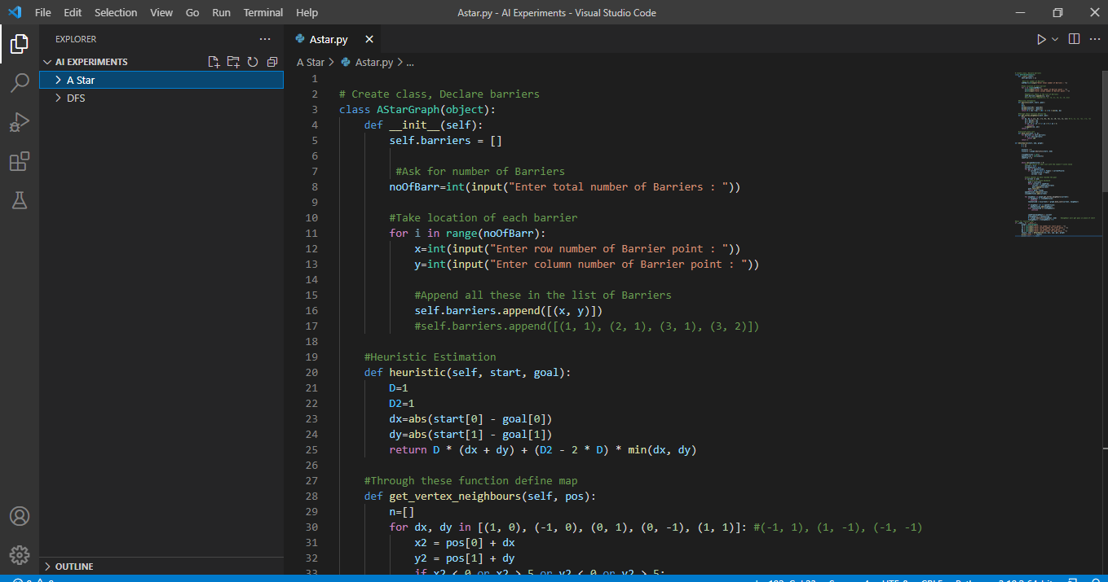

**(Implementation Part : 1)**

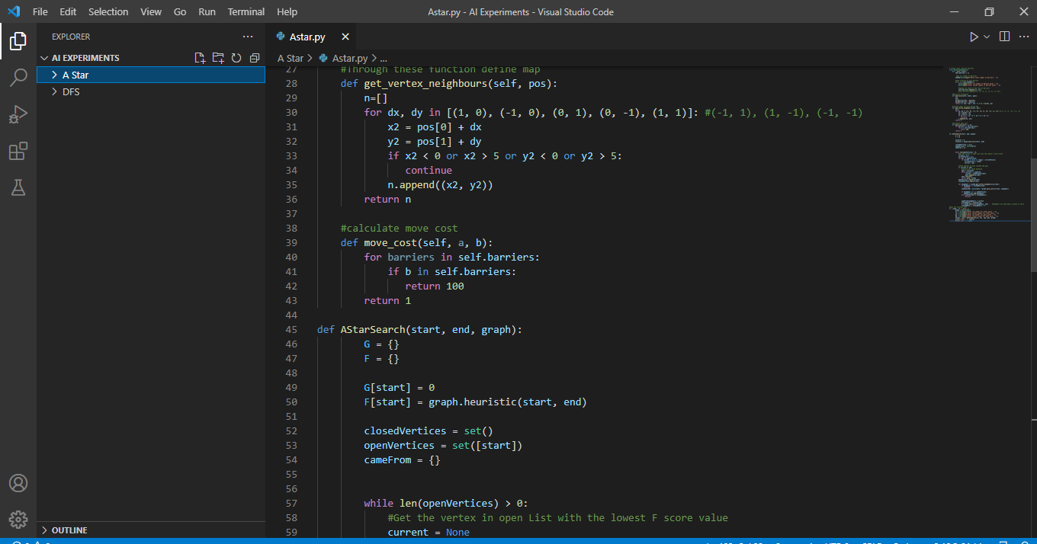

**(Implementation Part : 2)**

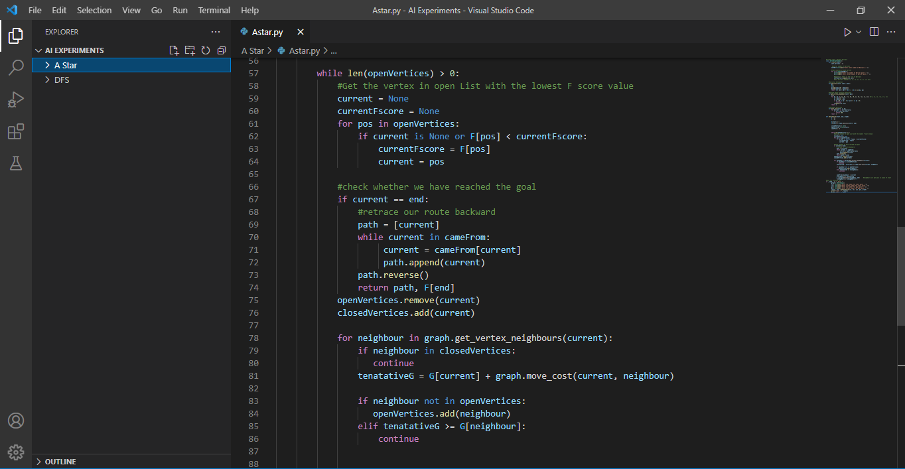

**(Implementation Part : 3)**

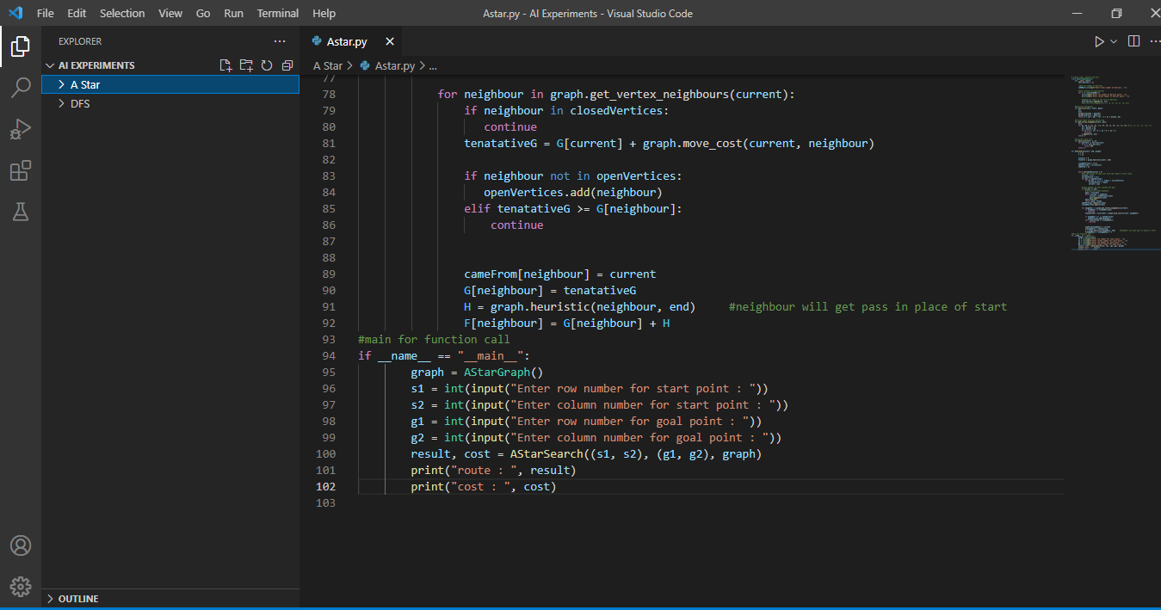

**(Implementation Part : 4)**

**Output :**

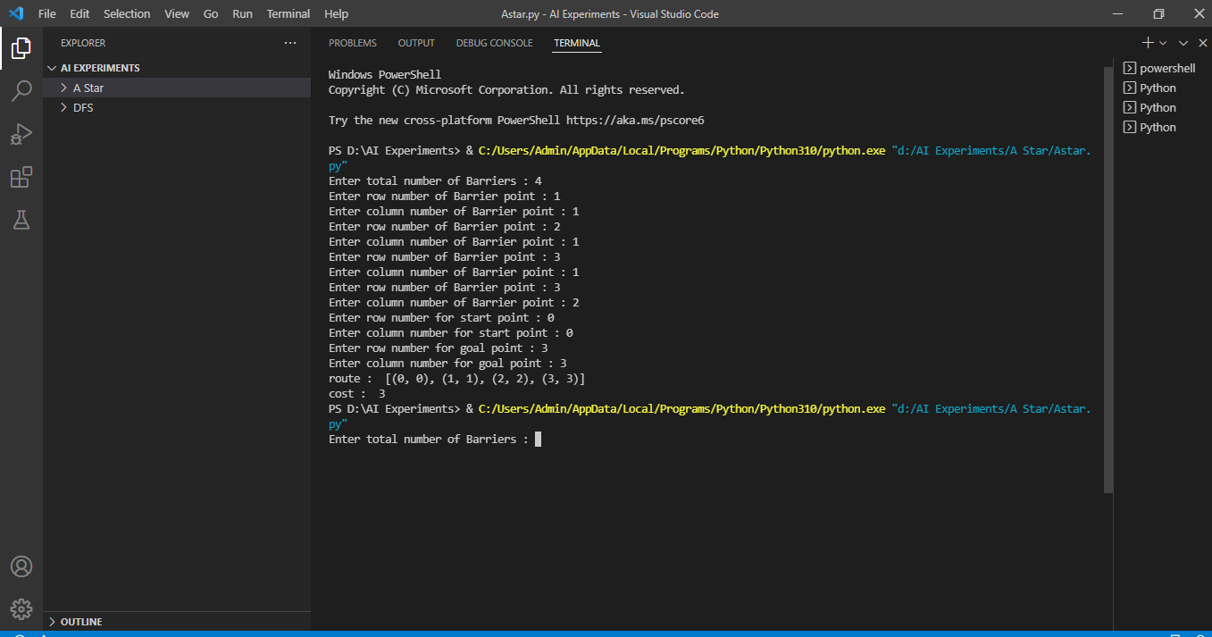

**(Output Of A* Search Algorithm)**

**Conclusion:**  I learned how to implement A* Search Algorithm.